Python

Python Installation

<https://www.python.org/>

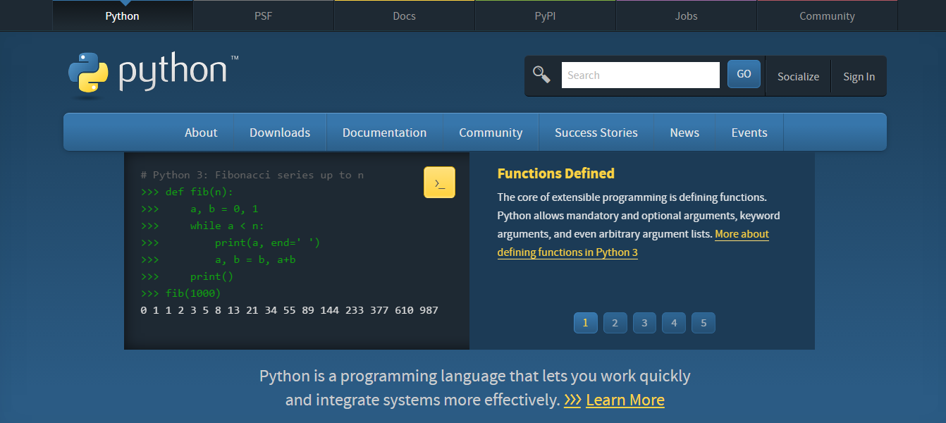

Download Python from <https://www.python.org/downloads/>

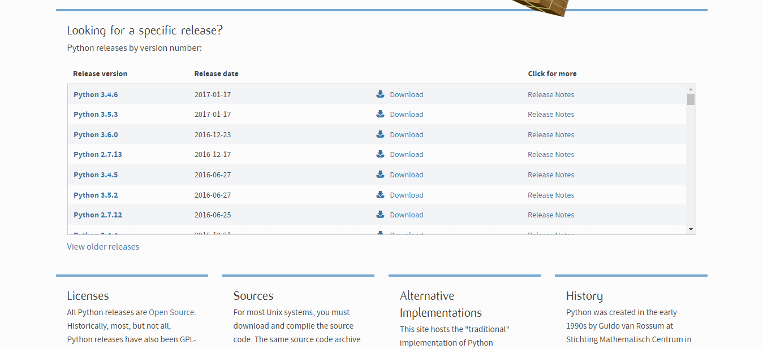

Select the version you want to install

<https://www.python.org/downloads/release/python-353/>

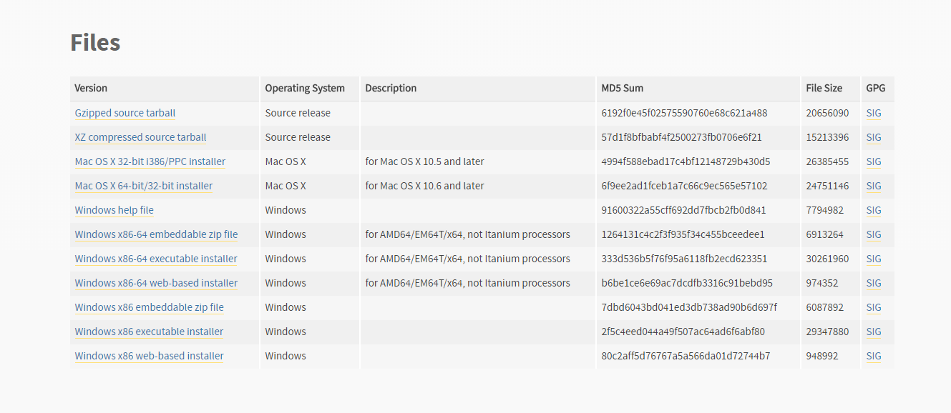

Now select the type of installation you want like zip or installer and downloading will start.

Now you will have a installer. Open the installer

To Install Python in Eclipse

Visit <https://www.ics.uci.edu/~pattis/common/handouts/pythoneclipsejava/eclipsepython.html>

You will find screenshots of installing python in eclipse

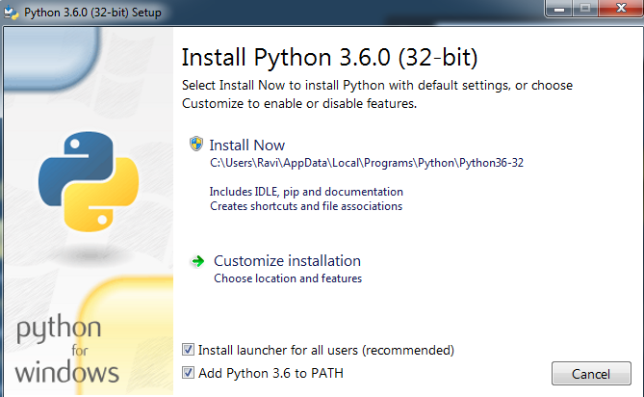

Check the Box Add Python 3.6 to PATH and Install it…..

But if you want to change path for installation then pick **customize installation** and change path of installation. (Recommended)

After Installation check whether python is installed.

Open command prompt and type python

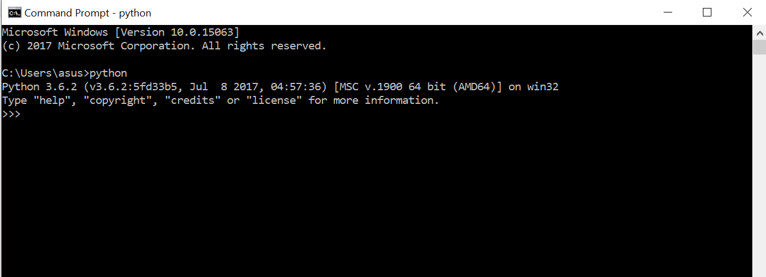

If it get executed then it means python is successfully installed.

Steps for installing Pygame

Go to location where python is installed.

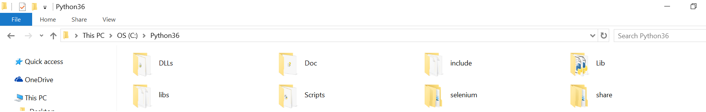

Open command prompt at that location.

To open command prompt at that location just type cmd on address bar of that location and hit enter.

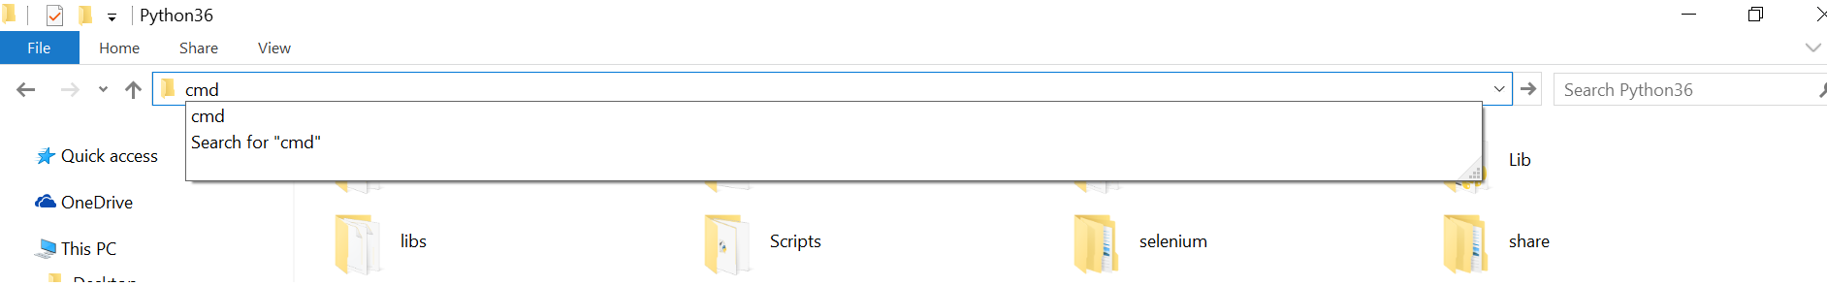

So cmd will open at this location and type **pip install pygame**.

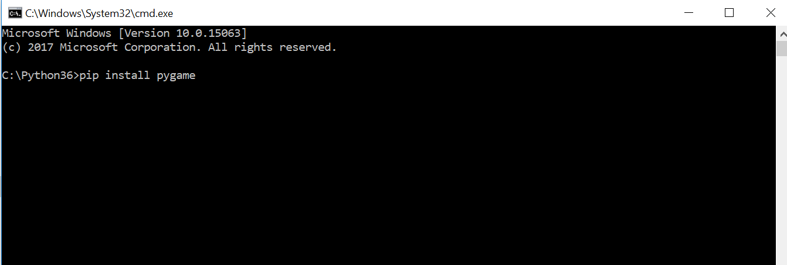

That’s all you need to do before executing pygame.

­

For code visit

https://github.com/ravi4all/DcrustPython